The Effect of Covid-19 on Consumer Uncertainty

Maurice Freese
Oberlin College

December 2022

1. Introduction
U.S. SARS-CoV-2 was first publicly acknowledged by the World Health Organization (WHO) on January 5, 2022, as a “new virus,” and later, on March 15th, 2020, the United States began lockdowns to limit the spread of the virus. The effect on consumers has been unprecedented and is still being assessed as more data is gathered. In effect, consumers have had to alter living, social, and consumption habits to try and overcome this global pandemic.
This study analyzes the effects of COVID-19 on consumer uncertainty. Consumer uncertainty can influence economic cycles via their effects on consumption, borrowing, and investment. This study measures that uncertainty using the Consumer Confidence Index (CCI), an important forward-looking economic indicator used to forecast consumption and other economic variables. It is derived from surveys of households’ current and future expectations of various economic conditions (labor markets, spending attitudes, finances, inflation, …etc. (Freese 2019). The Conference Board releases the CCI on the last Tuesday of each month, and the last reading for October 2022 stood at 102.5. The CCI is indexed to equal 100 in 1985. Hence, a monthly reading of 100 points implies that consumers are as optimistic as they were on average in 1985. In general, readings above 100 reflect optimism, and readings below 100 indicate pessimism.
This measure of uncertainty has fallen in response to negative shocks, whether economic, geopolitical, or social. As shown in Figure 1, some of the biggest decreases, abstracting from trends, in consumer confidence have been shocks from the Gulf War, when it fell from 101.7 to 84.7 in the month when Iraq invaded Kuwait, down to a low of 59.4. The 2001 recession intertwined with the catastrophic event of 9/11, from an optimistic 116.9 to a very pessimistic 84.9. During the Great Recession, the CCI fell from 90.6 to 47.4 and during the COVID-19 Recession, the index plunged from 132.6 in February 2020 to 85.7 in April 2020.

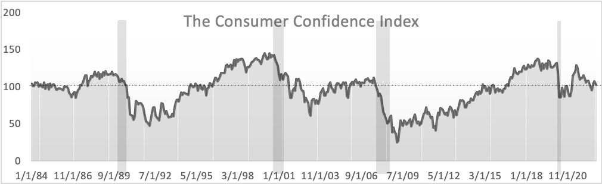
Figure 1: The Consumer Confidence Index
(Source: The Conference Board (Index 1984=100))

To more rigorously analyze how consumer confidence was affected by the pandemic, this study models the CCI using ordinary least squares and a quantitative analysis focused on correlation and effect size via coefficient estimates. OLS models are estimated using samples that end just before the pandemic hit the U.S. (2020:02) and samples that extend through the pandemic. For the latter, we test various COVID variables to better understand how the pandemic unsettled consumer confidence. The study can inform policymakers, other economic actors, and researchers about how pandemics and other unusual events affect consumer confidence by testing the impact of other unusual shocks. We will first develop two models before and after February 2020, the onset of the coronavirus. Then, we will specify significant Covid-19 variables and determine their effect size on CCI.
2. Model Framework
This study estimates Ordinary Least Squares (OLS) regressions, which are widely used in the social sciences, especially in economics. A variety of estimation approaches are used in various studies to analyze Covid-19 effects, such as Papadamou et al. (2020), who used panel data analysis, Mukhauyar et al. (2021), who estimated through the use of Vector Autoregressive Moving-Average models with Exogenous Regressors (VARMAX) Model, Hashmi, Chang, and Rong (2021) and Koçak & Baris-Tüzemen (2022) estimated COVID effects on E7 stock indices using quantile regressions, Jiao, Chen, and Azimian (2021) used Ordinary Least Squares, Geographically Weighted Regression, and random forests, and finally Teresiene, et al. (2021) used OLS regressions to assess the reactions of households and business leaders to COVID-19.
The use of OLS affords two major advantages in the current study. First, the regression framework is one of the most basic and widely accepted regression techniques (see ClockBackward, 2009). Second and more importantly, is that OLS is one of the best methods to estimate relationships in a multivariate model such as this one and obtain the most efficient and unbiased estimates among available models provided that the data meet the assumptions of the Gauss-Markov Theorem. OLS has some potential pitfalls because the framework may not handle challenges posed by noisy variables, dependence among the predictor variables (which can bias estimates), and heteroscedasticity. This problem is evident when trying to model the effects of COVID due to the natural structural multicollinearity that occurs when trying to link such variables as consumer uncertainty, total deaths, total cases, etc. These obstacles can be mitigated by dropping variables—according to their variation inflation factor—that are highly correlated with fellow independent variables as shown by Chan, et al. (2022). As Vynck (2016) explains, to correct heteroscedasticity, one could use a Lasso Ridge regression, Weighted Least Squares (WLS), or heteroscedastic-robust standard errors and coefficients and assess which approach fits the data better. In the models estimated in the study, modifying OLS models to include lags, first differences, and dummy variables is sufficient to address these issues.
3. Data and Research Methodology
Most of the COVID variables used are derived from data available by Our World in Data (OWID), an open-source platform with “Research and data to make progress against the world’s largest problems” (OWID). Economic variables are sourced from the Bureau of Economic Analysis, the Bureau of Labor Statistics, the Federal Reserve, and the Institute of Supply Management. Correlation and effect size analysis was adopted to measure the correlation between proxy variables and to measure the effect and correlation of economic and COVID-19 variables. The dataset consists of 505 monthly time series observations in the pre-COVID-19 sample and 536 in the sample that also spans COVID. The start of the sample periods reflects the use of lags and that the CCI became available on a continuous monthly basis in June 1997. Some samples end in January 2020, while the second model continues to the present day. COVID data was exported from OWID’s GitHub repository. Regression and statistical analysis were conducted using Python (v3.10.8) and RStudio.
To assess the effects of COVID-19 this study uses time series measures of COVID’s effects on health or government policies rather than a simple dummy variable equal to 1 since March 2020. The reason is that COVID-19’s effects on human health and policy are time-varying and have not been constant since early 2020. As stated below, the following hypotheses are assessed:
3.1 Baseline Model of Consumer Confidence, Pre-Covid
This section estimates OLS models of consumer confidence in samples excluding and then including observations from the pandemic. We need to first estimate the behavior of consumer confidence before the pandemic. Having a baseline model will then enable us to later extend the sample to cover the pandemic and statistically assess directly measurable COVID effects from adding COVID variables. The pre-COVID model is as follows:
(1)
CCI1 through CCI7 is a lagged dependent variable, with the following numbers corresponding to the lag, t-n. We utilized lags in the predictor variable to account for autocorrelation since with an index the this, present values are going to be influenced by past values. CPIYOY1 and CPIYOY2 is the first and second lag for our measurement of inflation, CPI Year-Over-Year. This economic driver first off will show a covid effect on inflation due to its coefficient estimate increasing or decreasing and, we can smooth out cycles and mitigate correlation due to the same reason mentioned for CCI.
To account for business cycle effects, it was decided to use the Institute of Supply Chain Management’s (ISM) index of manufacturing activity, also known as the Purchasing Managers Index. It is one of the few proxies for the business cycle that is continuously available at a monthly frequency. Like the CCI, is derived from a survey. Purchasing managers at over 300 of the most well-known manufacturing firms are surveyed about whether different aspects of manufacturing activity are rising or falling. This index is released on the third Thursday of each month. Index values (ISM_MAN) above 50 indicate that overall manufacturing activity is expanding and values below 50, that it is contracting. The ISM manufacturing index is a contemporaneous indicator that is positively correlated with real GDP growth. For this variable we have lags at t-1, t-2, and t-3, represented as ISM_MAN1, ISM_MAN2, ISM_MAN3, respectively.
Pre-COVID model above reflects lags of CCI1 through CCI7, CPIYOY1, and ISM_MAN1ST1 through ISM_MAN1ST3. These were essential in building an OLS framework that meets assumptions critical for the model to be valid. To investigate the expectations in violating autocorrelation we are going to verify through plotting the Auto Correlation Functions (ACF) and the Partial Auto Correlation Functions (PACF) seen in Figure 4. The PACF are the topped with orange dots while ACF is topped with navy blue.
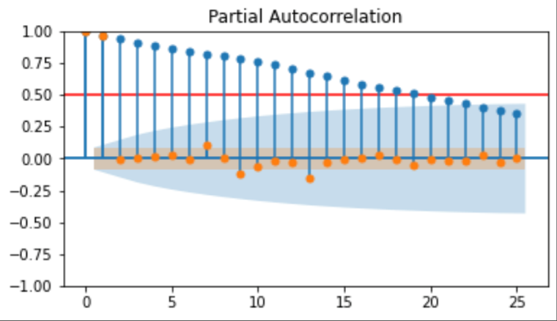
Figure 2: ACF Plot of the Consumer Confidence Index
(Source: The Conference Board

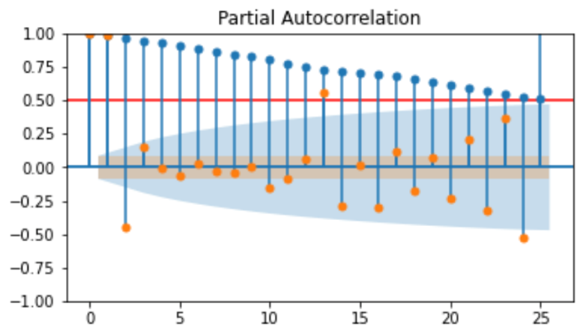
Figure 3: ACF Plot of Year-Over-Year CPI Inflation
(Source: BLS)

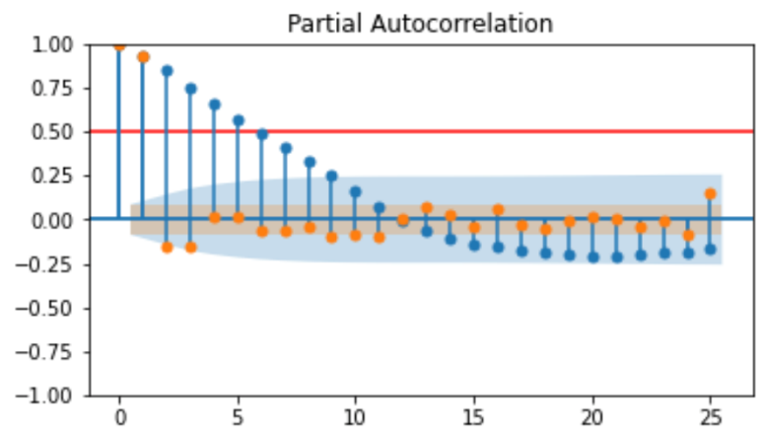
Figure 4: Institute for Supply Management (ISM) Manufacturing – Purchasing Managers Index ACF Plot
(Source: Institute for Supply Chain Management)
The ACF and PACF plots in Figure 4 verifies the expectation that the regression will need to address autocorrelation in the data. In particular, they imply that we should more closely examine the (PACF) plots to help determine lag lengths on consumer confidence, consumer price index year-over-year and the ISM index. Multiple lags for the CCI, CPIYOY, and ISM_MAN are included to mitigate autocorrelation and to smooth out business and economic cycles to allow us to detect any unusual COVID-related effects in recent years.
When addressing multicollinearity or using a variable with an obvious trend, first differencing variables can help, as emphasized by Toutenberg and Trenkler (1998). This was the case for using the ISM manufacturing index in the CCI model. To address the obvious trend in the ACF plot above the first difference of the variable was taken and reevaluated. As shown in Figure 5, first differencing largely addresses the auto correlation in the level of the index. Nevertheless, there can be some lagged effects of the business cycle on confidence, and experimentation with lag length indicated that the t to t-2 lags were significant and their inclusion helped prevent serial correlation in model residuals.
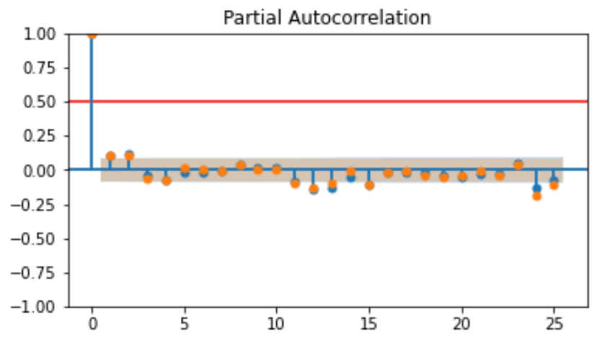
Figure 5: First Difference ACF for the Manufacturing Purchasing Managers Index (Source: Institute for Supply Chain Management)
The model follows Bordo and Duca (2021) in including seven other variables to control for exogenous shocks that are not reflected in lags of the CCI, lags in CPI inflation, and lagged changes in the ISM index that help control for cyclical and general economic factors. The exogenous shock variables include BEARD, GULFWAR1D, GULFWAR2D, DEBTCEILING2011D, STOCK87D, FCRISISD, and 9/11D. These variables were chosen out of testing many other historically significant events, including Russia invading Ukraine, Greece Debt Crisis’s, Obama Election, Trump Election, Biden Election, and January 6th just to name a few.
BEARD is a dummy variable equal to 1 from February 2008 to April 2008, when people reacted to news that the large investment bank Bear Stearns was beginning to fail until it was rescued by being bought by the large commercial bank, JP Morgan Chase (see Reuters (2008) for details on the buy-out). GULFWAR1D is a dummy variable equal to .33 from August through October 1990 and -1 in March of 1991. The .33 represents the build-up of troops in the middle east after Saddam Hussein invaded Kuwait and the -1 is the end of the first Gulf war. GULFWAR2D is a dummy equal to 1 in January and February 2003 to capture the negative effect on confidence of the impending United States invasion of Iraq and -1 in April and May recognizes President George W. Bush ending operations in Iraq. Americans became uncertain and their anxiety rose in reaction to news reports of the likely military action, declines in stock prices and increases in oil prices.
DEBTCEILING2011D is a dummy variable equal 1 in July and August 2011 and -1 in November and December. The national debt level had soared during the Great Recession, and Republican leaders were pushing for large spending cuts in exchange for allowing the Treasury to borrow more (see Logan 2020). If the debt ceiling were not raised, the U.S. would likely have defaulted on paying some of its debts, and this possibility hurt consumer confidence. DEBTCEILING2011D equals -1 in November and December 2011 when confidence recovered after the crisis was resolved.
STOCK87D is a dummy variable equal to 1 in October and November 1987 for the Stock Market Crash of 1987, also known as “Black Monday” (Federal Reserve History, 2013). This is known as the first contemporary global financial crisis because in one day the Dow Jones Industrial Average fell 22.3%. (Yahoo Finance). STOCK87D equals -1 in December 1987 and January 1988 to capture the reversal of the confidence plunge as the public fear of another Great Depression unwound. These proxy variables were chosen from a larger group in the process of building a baseline model specification. FCRISISD is a dummy variable that equals 1 in October 2008 to represent the month that markets across the world plummeted to numbers seen in the crash of 1987. D911 is a proxy variable that equals 1 in October of 2003 to signify the 9/11 attack on the World Trade Center and the consumer confidence survey picking up that reaction in October.

DUMMY VARIABLES
Variable | Start date | End date
BEARD | M02/2008 | M04/2008
GULFWAR1D | M09-M10/1990 | M03/1991
GULFWAR2D | M01/2003 | M02/2003
DEBTCEILING2011D | M07/2011 | M09/2011
STOCK87D | M10/1987 | M11/1987
D911 | M10/2003 | M10/2003
Table 1: Model 1 Exogenous Shock Variables
3.2 Modeling Consumer Confidence Over the Pandemic
To assess for the direct impact of COVID on consumer confidence, several COVID variables are added to Model 1 for samples extending into the pandemic:
 (2)
Model 2 expands on Model 1 by adding controls for the effects of COVID that are not reflected in economic variables, such as inflation or the ISM index. These COVID variables are based on previous research by Bordo and Duca (2021), Teresiene, et al. (2021), and Elmassah, et al. (2022). Two additions to Model 1 include new deaths per million attributed to COVID-19 (NEW_DEATHS) and the change in this variable (NEW_DEATHSDELTA). A third variable is GOVT_STRING, which tracks the stringency of U.S. government-related regulations and policies as measured by the Blavatnik Center at Oxford. A fourth COVID variable VAXSTRING multiplies the government stringency index by the prior month’s share of the population that is fully unvaccinated. Ostensibly as the share of the vaccinated rises, the impact of mandates is reduced as more people are protected against the severity COVID infections. The selection of COVID controls was based on previous research and the effect of including them in regressions.
The government stringency index used is calculated by the Oxford Coronavirus Government Response Tracker (OxCGRT), which calculates the stringency index for many countries based on the mean value of 20 COVID related metrics. Those inputs include public information campaigns, workplace closures, school closures, public transport closures, restrictions on public gatherings, public event cancellations, international travel controls, and internal movement restrictions (OxCGRT 2020). GOVT_STRING is used in the calculation of the vaccine stringency, , where vaxfull is the share of fully defined as people who have had the first two vaccinations for COVID. GOVT_STRING and VAXSTRING have minimum values of 0 and maximum values of 100.
Descriptive Stats of Dependent and Independent Variables

Variable | Obs | Start Date | Mean | SD | Median | Min | Max | SE | Skew
CCI | 545 | M06/1977 | 94.82 | 24.39 | 97.50 | 25.30 | 144.70 | 1.04 | .25
ISM_MAN | 669 | M01/1967 | 52.73 | 6.26 | 53.40 | 29.40 | 72.10 | 0.24 | -0.60
CPIYOY | 550 | M01/1977 | 3.65 | 2.82 | 2.90 | -2.00 | 14.60 | 0.12 | 1.70
GOVT_STRING | 699 | M02/2020 | 2.47 | 11.64 | 2.47 | 0 | 72.69 | 0.45 | 64.79
VAXSTRING | 669 | M02/2020 | 1.79 | 9.70 | 0 | 0 | 72.69 | 0.38 | 6.10
NEW_DEATHS | 669 | M02/2020 | 52.32 | 287.71 | 0 | 0 | 3096.00 | 11.12 | 6.71
Table 2: Descriptive Statistics of Model Variables
(Sources: BEA, BLS, ISM, Our World In Data (OWID), and author’s calculations)

4. Results and Interpretation
After discussing the non-COVID controls for exogenous shock, this section assesses the effects of COVID by estimating OLS regressions and by conducting ANOVA analysis of Models 1 and 2.
4.1 Non-COVID Exogenous Variables
Figures 5-7 provide short time series plots of consumer confidence from 3 months before to three months after the time when each exogenous variable differed from 0—as depicted by the blue-shaded box in these plots. These before and after periods help the reader visualize the trend in consumer confidence, its deviation from “normal” (trend), or periods not affected by the shock proxied by the dummy variable in question.
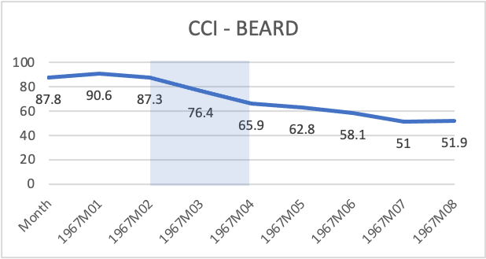
Figure 5: Effect of BEARD on CCI
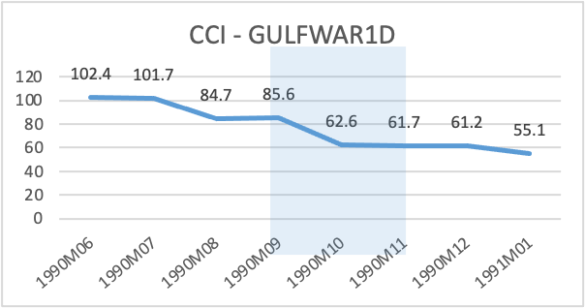
Figure 6: Effect of GULFWAR1D on CCI

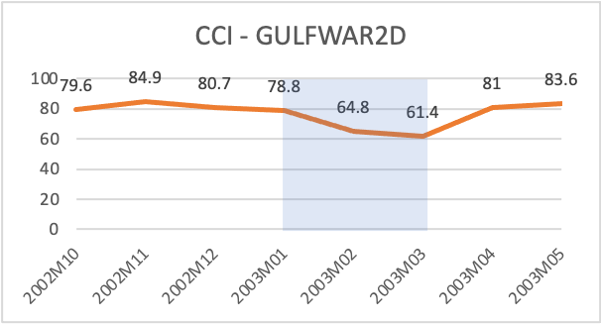
Figure 7: Effect of GULFWAR2D on CCI
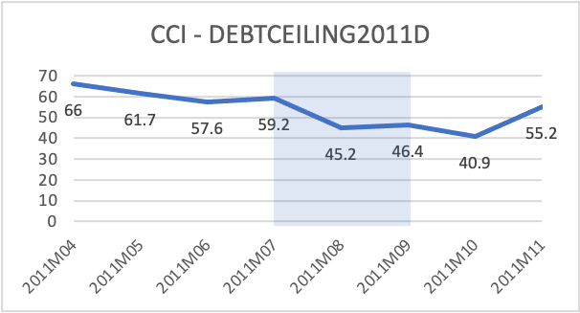
Figure 8: Effect of DEBTCEILING2011D on CCI
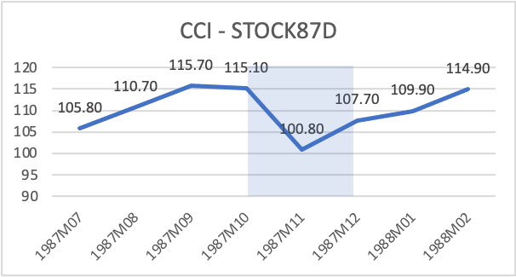
Figure 9: Effect of STOCK87D on CCI

As reflected above, consumer confidence was rising before each episode of an event that increased uncertainty. Of these, the smallest absolute decline during the exogenous events was for STOCK87D when consumer confidence initially fell 12.4% in the first month. In contrast, confidence fell by almost twice as much during the uncertainty surrounding the failure of Bear Stearns (BEARD), the 2003 Gulf War (GULFWAR2D) and the debt ceiling crisis of 2011 (DEBTCEILING2011D), posting corresponding declines of 24.5%, 22.1%, and 21.6%, respectively.
To test and ensure that a relationship with the proxy variables and dependent variable exists this section conducts an Analysis of Variance (ANOVA) on the exogenous variables. ANOVA is a preferred method in quantifying correlation with a binary independent variable and continuous dependent variable. Keeping the Null hypothesis in mind,
An ANOVA table is created using R Studio to obtain the F-Critical Values to test our hypothesis, which entails using significance levels and degrees of freedom, qf(p = .025, df1 = 501 (n-1), df2 = 488 (n-k)). The choice of a two-tailed ANOVA and not a one-tailed ANOVA is made based on movements on both sides of the F-distribution, for which the critical value is 1.592121. Hence, an F-value that is greater than the critical value fails to reject the null hypothesis.

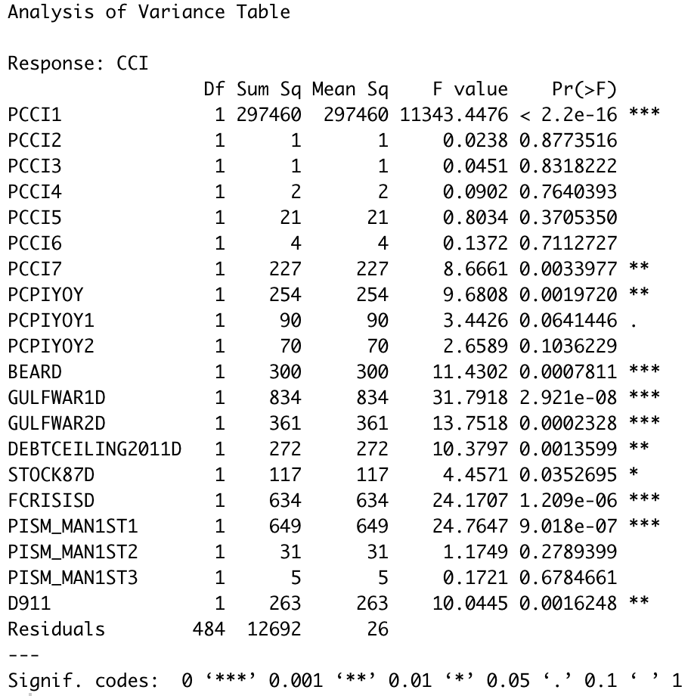
*The “P” in front of the variables denotes the pre-covid time series variables from the variables including covid.
Figure 10: Analysis of Variance for Model 1
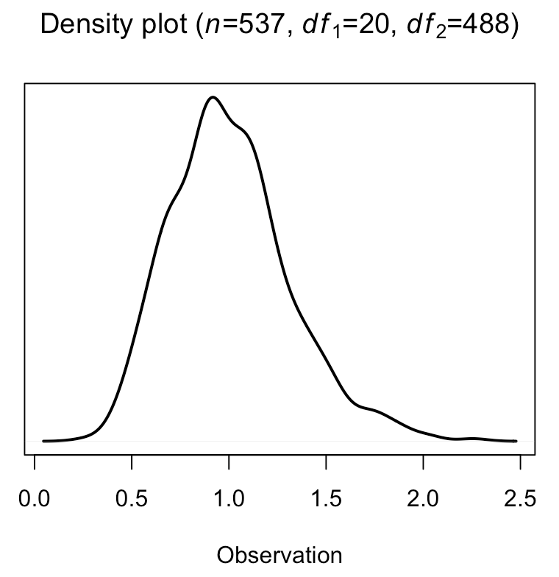
Figure 11: Density of F-Distribution at 505 observations

As reported in Figure 9, all the F-values in the red boxes are well above the critical value of 1.592121 failing to reject . This implies that CCI1, PCPCPIYOY, and PISM_MAN1ST1 are all significant at the one percent level, while the exogenous shock variable STOCK87D is significant at the 5% level. Figure 10 plots the density of the F-distribution, which is slightly skewed to the right. These considerations imply that at the five percent significant level, Model 1 explains a significant level of the variance with normally distributed F-distribution that is normally distributed (it’s distribution is slightly—but not significantly—skewed a little to the right.
With the ANOVA table supporting the possible use of OLS, Figure 11 presents estimates of estimating Model 1 over the pre-COVID sample. With the exception of some lags of the CCI, ISM index, and CPI inflation, all variables in Model 1 are statistically significant at the five percent level, with FCRISISD having the coefficient with the largest absolute magnitude, along with a highly significant F-exclusion test statistic and correspondingly low p-value. The corrected R-square is high (the green box in Figure 11), indicating that the model explains 95.8% of the variance in the consumer confidence index, which is consistent with the earlier ANOVA. Also, as seen in the blue box, the F-statistic’s p-value is less than our significance level, so we can conclude that this model fits the data presented better than a model with no independent variables.
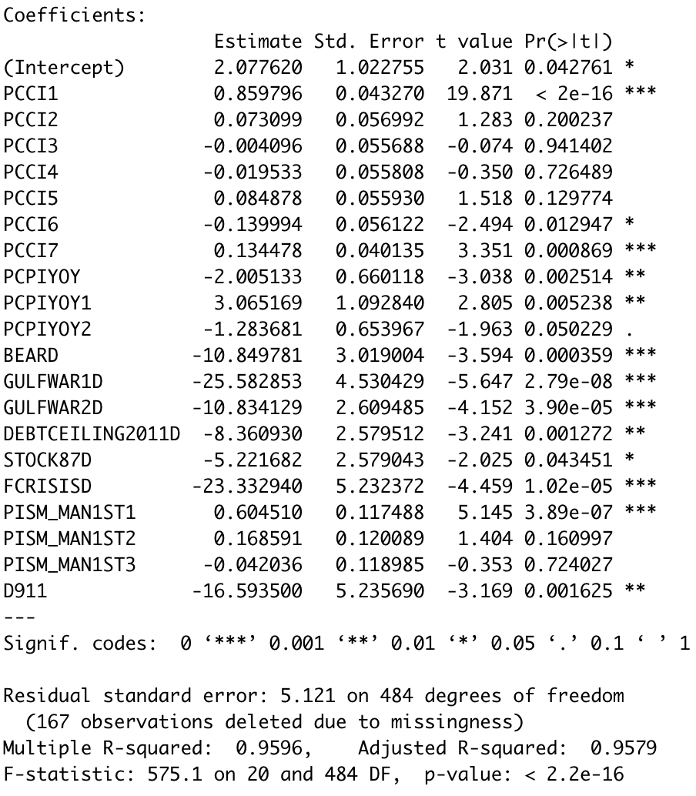
Figure 12: Regression Results for Model 1
As indicated in Figure 3, the ACF plot recommended including the t-1 lag of CPI inflation, PCPIYOY1. Holding all else constant, if the one-year lag of CPI inflation rate increased by one percent, the CCI would increase by 3.07 points whereas an increase of one percent in the contemporaneous CPI inflation rate would have an effect of contribute to a fall of 2.01 points. The ANOVA table in Figure 10 indicates that when looked at in isolation, CCI6, CCI7, PCPIYOY1, and BEARD were still significant—but by not as much—as in the OLS estimates of Model 1—while PCPIYOY2 and STOCK87D were only marginally significant at the ten percent level. The stronger OLS results indicate that for these variables their significance is higher when using a methodology that accounts for the influence on their significance stemming from the inclusion of the other variables.
The estimated coefficients on the shock variables indicate that the shocks had sizable and statistically significant negative effects on CCI, as expected. The only event outside of a one percent significance level is STOCK87D which had a p-value increase of .008 and the smallest estimate of -5.2. If the collapse of Bear Stearns companies, first Gulf War or the second Gulf War lasted an additional month, the Consume Confidence Index would have decreased by 10.9 points, 25.6, and 10.8 points, respectively. The debate on raising the United States Treasury debt ceiling in 2011 lowered the CCI by an estimated 8.4 points. As shown in the figure below, FCRISISD has a higher Adjusted further confirming the coefficient estimates in the regression table. Each of the plots begins three months before and after the shock in each variable began and ended, respectively. Another feature of the plot to explain the dramatic difference in the shock effects is the slope of the trend line. As shown for STOCK87D the slope is .2548 and FCRISISD at -4.2167. If you go back to the ANOVA and regression results you will see how there is a correlation between figures and tables further reflecting correlation and size of effect using estimates.
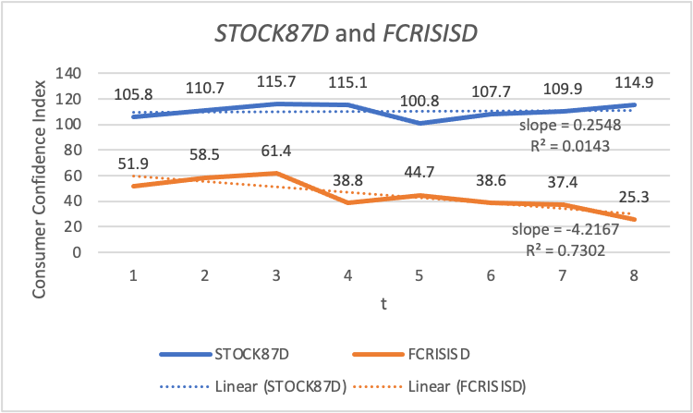
Figure 13: Comparison of STOCK87D and FCRISISD

Interestingly the first difference in the supply chain management variable, PISM_MAN1ST1, does not have that large of an effect on the Consumer Confidence Index. That is not surprising given that consumer spending habits drive business activity as reflected in the Purchasing Managers’ index due to household’s direct effects on the demand for manufactured consumer durable goods and household’s indirect effects on business’ demand for manufactured investment goods. Also interesting are the negative estimate of -2.0051 for PCPIYOY, the positive coefficient of 3.0651 for PCPIYOY1 and the negative coefficient (-1.2837) on PCPIYOY2. These shifts in signs on estimates can attributed to a minor case of multicollinearity and autocorrelation leading the mentioned estimates to be a little precarious. The minor degree of multicollinearity and autocorrelation comes from the structural nature of the data and was an issue at certain specification points. But as Gelman and Hill (2007) stress, the first lag of a variable is often correlated with other lags of itself and also with other independent variables in the regression, causing signs to sometimes be estimated incorrectly.
4.2 Model 2: Covid Treatment
To further assess the validity of Model 2, another ANOVA is conducted to examine any change, or lack thereof, in significance of the old variables and the new ones. In addition, the new continuous variables on COVID are assessed with the Pearson Correlation Coefficient to help verify their significance or lack thereof. Following these analyses, the study reviews OLS regression results from Model 2.
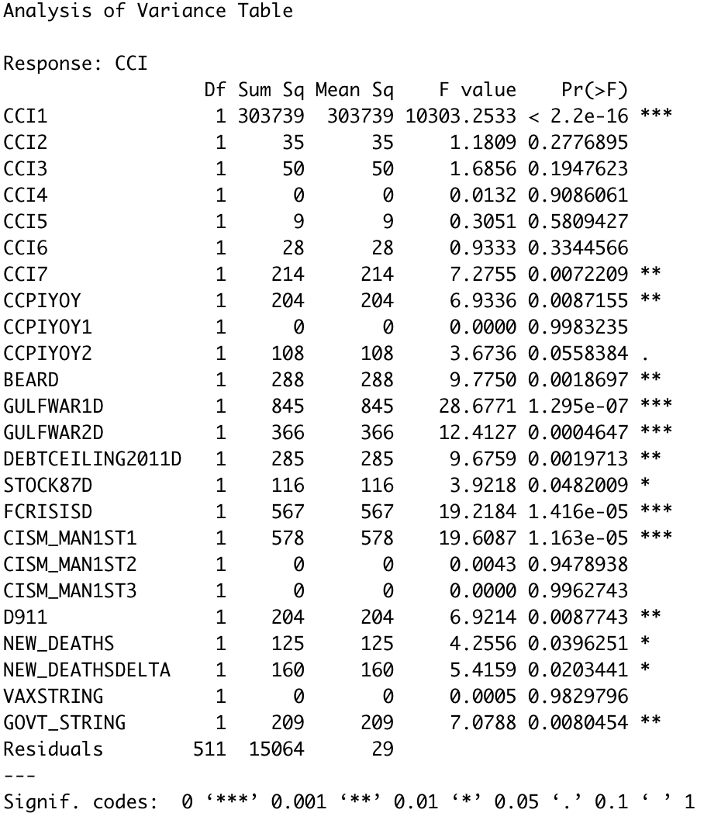
Figure 14: Model 2 ANOVA Table

The ANOVA analysis of some changes in Model 1 variables indicates that Model 1 is a valid model of pre-COVID consumer confidence. The critical F-Value for this case is 1.538688. The ANOVA table above shows that all variables under question except VAXSTRING is statistically significant within a five percent significance level. Due to the absence of some important data, the Covid-19 time series, I assumed some significance levels were going to shift. In this case, the most any significance statistic changed involved a loss or gain of significance. Compared to the first ANOVA table CCPIYOY1 and CPIYOY2 gained marginal significance at the ten percent level. The only dummy variable to shift significance level was BEARD from zero percent level to 0.1 percent level. The F-values, compared to the first equation ANOVA, had no significant swings that would affect failing to reject the null hypothesis. The F-Distribution density plot for this analysis is normally distributed and slightly skewed right, as is the case for Model 1.
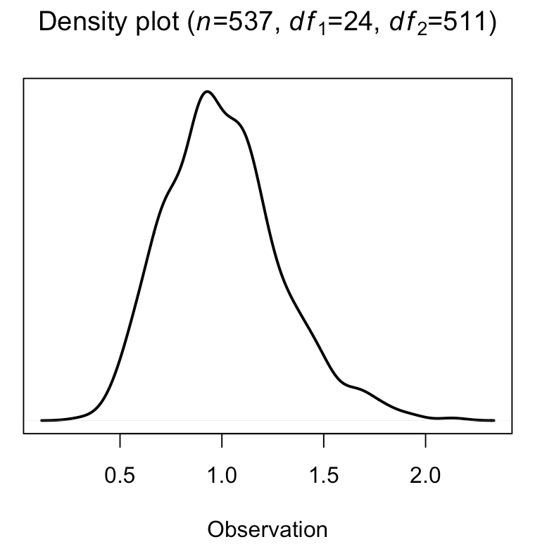
Figure 15: Model 2 Density of F-Distribution
Of the four COVID variables tested, three proved to be significant. NEW_DEATHS and GOVT_STRING are significant at the one percent level while NEW_DEATHSDELTA, or the change in deaths, is significant at the five percent level. It is not surprising that VAX_STRING is not significant, which does not reject the null hypothesis that the vaccine-adjusted stringency has no effect on the Consumer Confidence Index. The reason is that the effectiveness of the vaccines is reflected in the lower readings of NEW_DEATHS and changes in new deaths (NEW_DEATHSDELTA).
To further investigate the lack of correlation between a new independent variable and the dependent variable, we assess scatterplots according to the Pearson correlation with the dark gray band being the corresponding confidence interval. Notice the low correlation these variables have with CCI individually. This is just due to a limited 2-1/2 years of time series data on COVID variables whose linearity and correlation are harder to detect compared to other variables for which there are 20 to 60 years’ worth of time variation. The Pearson correlation coefficient measures a correlation value on a scale ranging between negative one to positive one, negative being inversely correlated and positive being correlated. As shown in the red squares, on their own these variables have no or little correlation with the consumer confidence index.
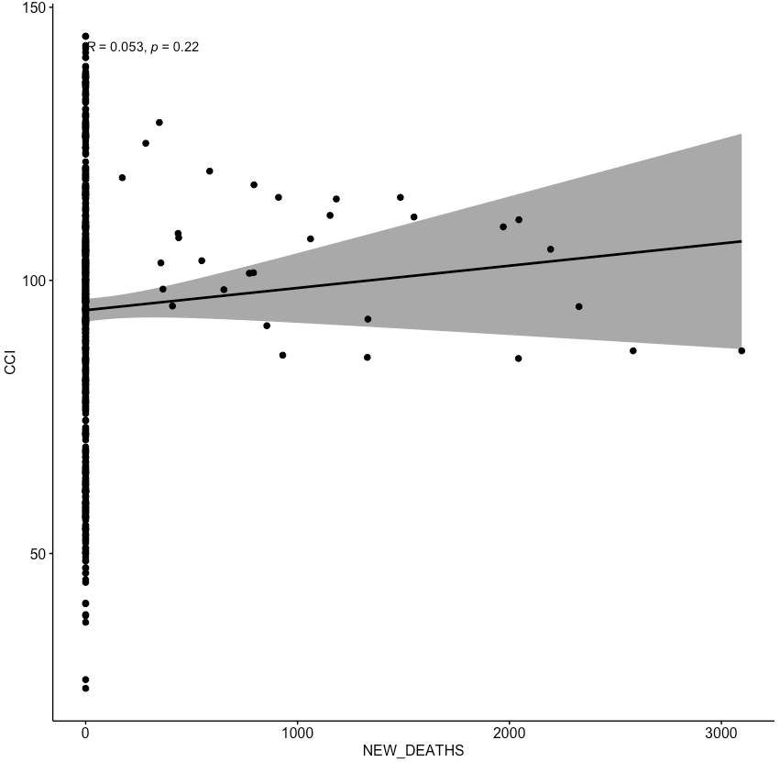
Figure 16: Pearson Correlation Coefficient Scatterplot of NEW_DEATHS
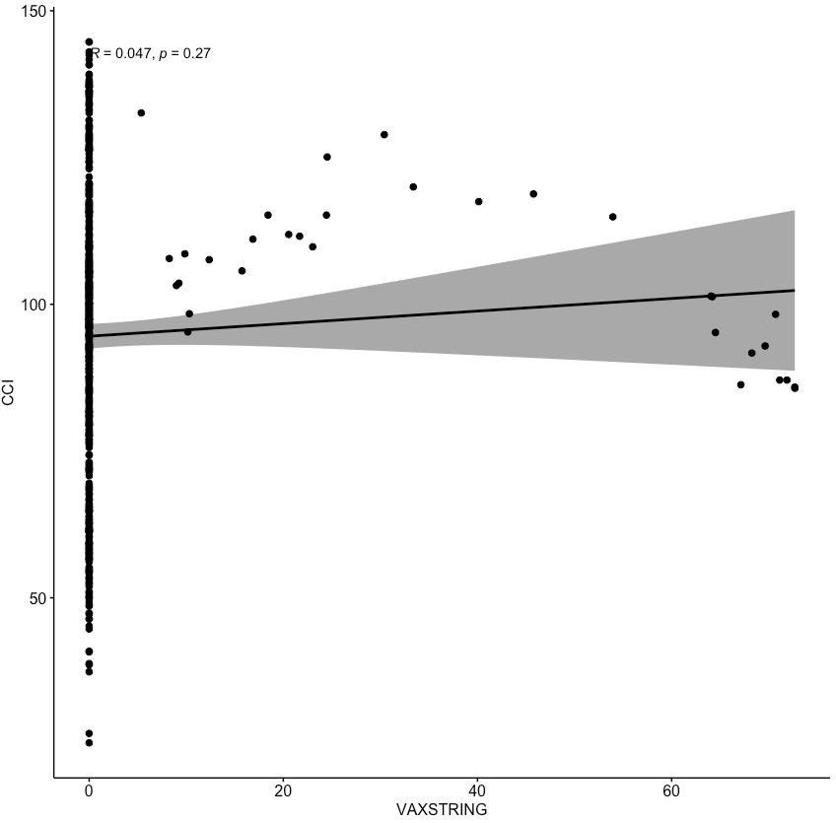
Figure 17: Pearson Correlation Coefficient Scatterplot of VAX_STRING
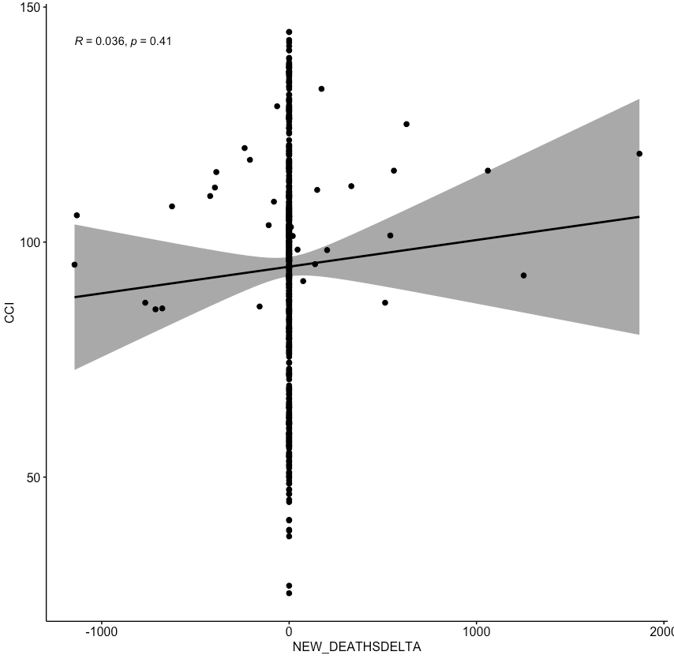
Figure 18: Pearson Correlation Coefficient Scatterplot of NEW_DEATHSDELTA
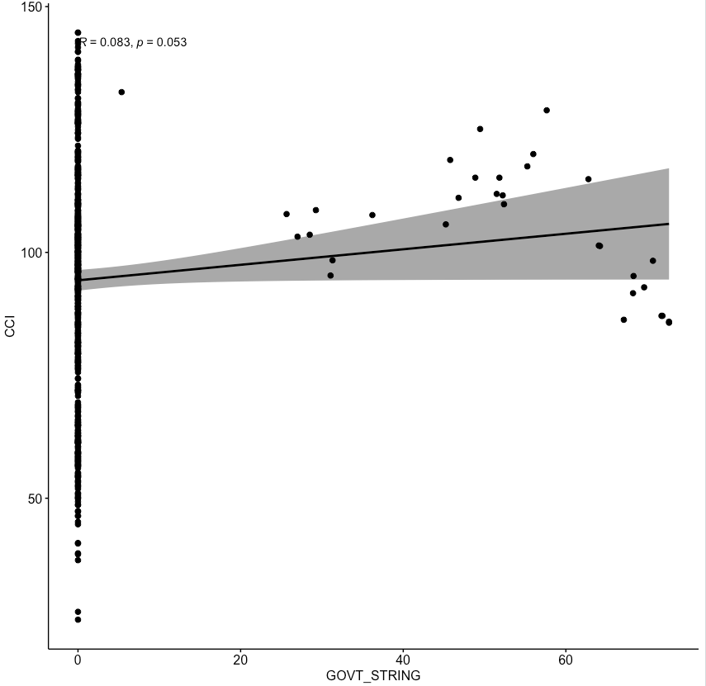
Figure 19: Pearson Correlation Coefficient Scatterplot of GOVT_STRING
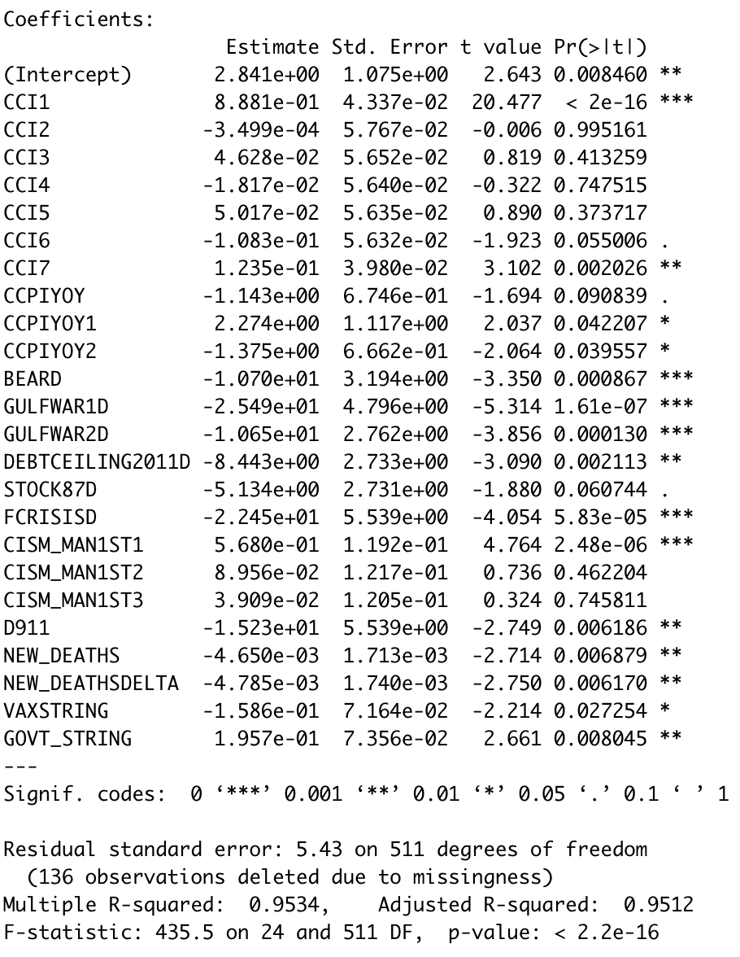
Figure 20: Regression Results for Model 2
As reported in Figure 20, the adjusted R-square of Model 2 implies that it explains 95.1% of the variance in the Consumer Confidence Index. This is about 0.67% less than the 95.8% for Model 1 which estimates confidence over a less tumultuous period. This small-sized decrease in model fit is of little surprise considering the second ANOVA analysis and the scatterplots with the Pearson Correlation Coefficient. Along with the F-statistic’s p-value of zero, the adjusted R-square of Model 2 reflects that it fits the data well.
An interesting result arises when the COVID variables in Model 2 are reduced to just including only NEW_DEATHS or NEW_DEATHSDELTA. As in Appendix A and B, the NEW_DEATHS and NEW_DEATHSDEALTA have a similar effect. However, NEW_DEATHS by itself is significant at the 15% level while NEW_DEATHSDELTA is only marginally significant at the 10% percent level:
Appendix B
Appendix B
The interesting part comes when they are paired together, they are both significant at the one percent level and their effect is magnified to as follows (also in regression table above):
Figure 21: Regression Results from Model (2) Figure 19
The estimates of the old variables in Model 1 and Model 2 do not move around too much, with the largest changes being less than one point in magnitude.
When it comes to the effect of the Covid-19 variables on households, the overall change in the model is minimal. For an additional new death related to the Coronavirus, one would see a .00465 point fall our measurement of consumer uncertainty, ceteris peribus. This makes sense because as shown in Table 2, the maximum value for NEW_DEATHS is 3,096, which if we multiply by the variable’s coefficient estimate, we can obtain an estimated the maximum effect of new deaths on consumer uncertainty. The peak monthly average daily death rate of 3,096 translates into lowering the Consumer Confidence Index by 14.39 points. This impact is historically large because this is a bigger decrease than the impact of the debt ceiling shock (DEBTCEILING2011D, -8.443-points) and the October 1987 stock market crash (STOCK87D, -5.134). On the other hand, a 1-point rise in VAXSTRING or GOVT_STRING would lower the CCI by 11.5 and 14.5 points, respectively, accordingly.
5. Conclusion
This study builds an estimable model of the Consumer Confidence Index and then modifies it to assess the impact of the COVID-19 pandemic. The paper finds that aside from its effects on economic variables, COVID has directly and negatively affected consumer confidence. One clear effect is tracked by the stringency of government restrictions and accounting for the share of the population that are vaccinated. The largest estimated COVID effects are from the pandemic’s impact on new deaths per million and the change in the new death rate. Both variables are statistically significant and have negative effects that are substantial in magnitude. The new death rate reflects the underlying mortality risk posed by the virus which has been mitigated by vaccinations. At its maximum monthly average reading, daily new deaths lowered consumer confidence by 14.4 points, compared to a decline of 15.2 points attributed to the September 2001 terrorist attacks.
There are some limitations of the analysis. One is that COVID effects are measured over a short period because no earlier pandemics were experienced in the history of this measure of consumer confidence, which is continuously measured since 1997 and intermittently tracked since the late 1950s. That said, the tailing-off of the new death rate and of the stringency of government mandates suggests that most of the time variation in the COVID effects is behind us, which mitigates the risk that coefficient estimates may appreciably differ as more time observations become available on the consumer confidence index. Another limitation is that OLS models have difficulty in parsing out marginal effects from variables that are multicollinear. Future research should assess alternative estimations approaches.

APPENDICES

Appendix A – MODEL 1 ANOVA

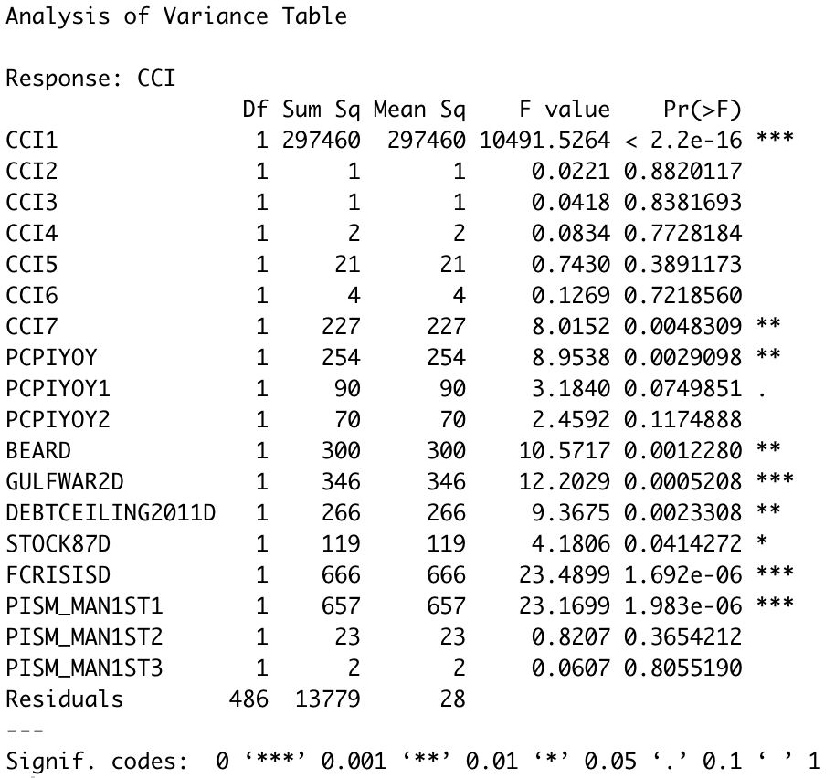
A

Appendix B – MODEL 1 REGRESSION RESULTS
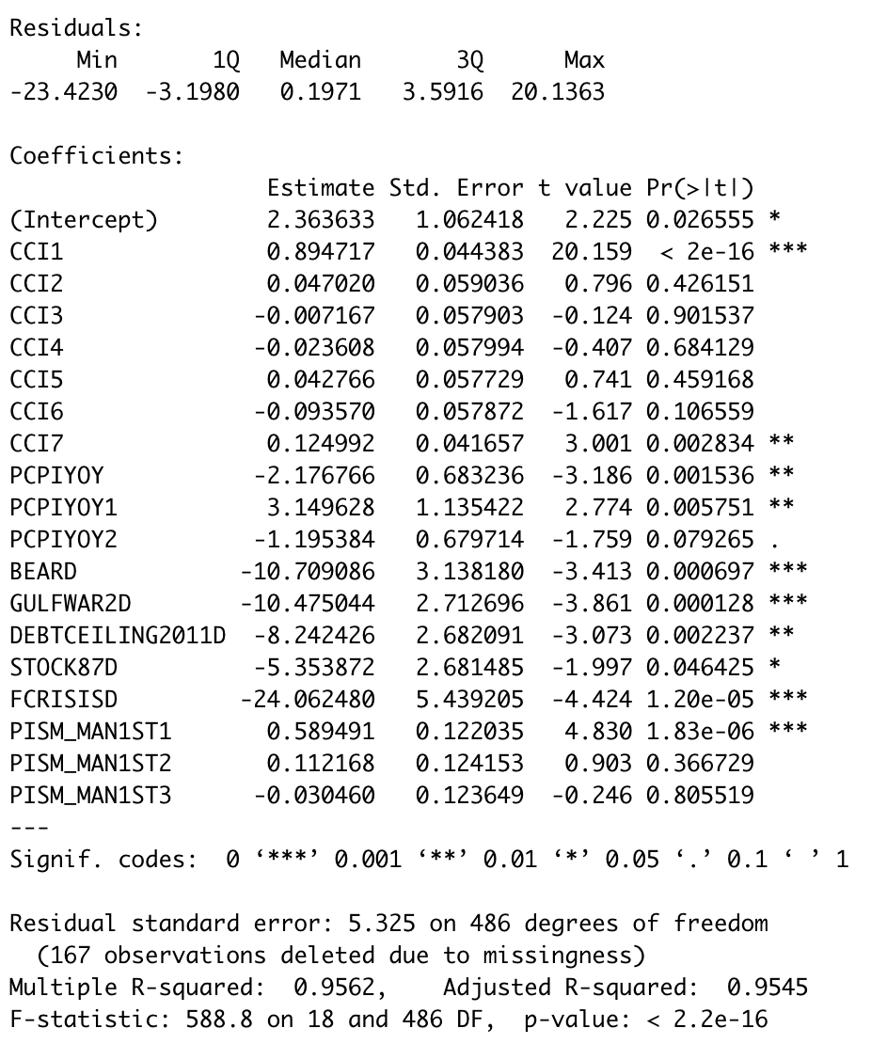

C – MODEL (2) ANOVA
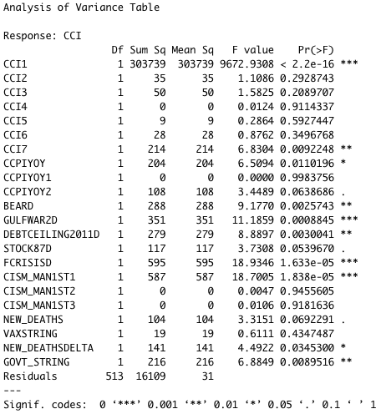

D – MODEL (2) REGRESSION RESULTS
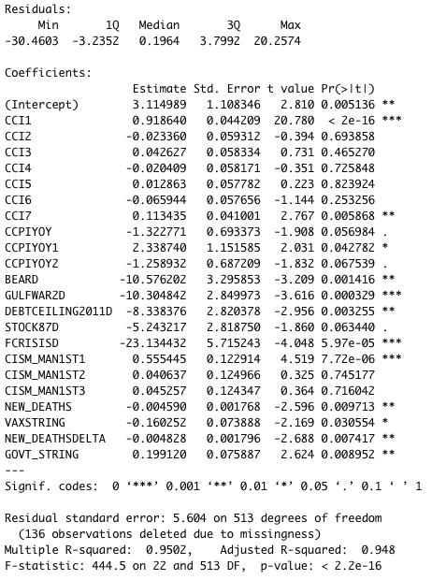

References
Bernhardt , Donald, and Marshall Eckblad. “Stock Market Crash of 1987.” Federal Reserve History, 22 Nov. 2013, https://www.federalreservehistory.org/essays/stock-market-crash-of-1987.
Bordo, Michael D., and John V. Duca. “How the New Fed Municipal Bond Facility Capped Muni-Treasury Yield Spreads in the COVID-19 Recession.” Federal Reserve Bank of Dallas, Working Papers, vol. 2021, no. 2101, Feb. 2021, https://doi.org/10.24149/wp2101.
Chan, Jireh Yi-Le, et al. “Mitigating the Multicollinearity Problem and Its Machine Learning Approach: A Review.” Mathematics, vol. 10, no. 8, 2022, p. 1283., https://doi.org/10.3390/math10081283.
“Dow Jones Industrial Average Historical Price Quotes.” https://finance.yahoo.com/quote/%5EDJI/history/. Accessed 28 Nov. 2022. Yahoo Finance.
Edouard Mathieu, Hannah Ritchie, Lucas Rodés-Guirao, Cameron Appel, Charlie Giattino, Joe Hasell, Bobbie Macdonald, Saloni Dattani, Diana Beltekian, Esteban Ortiz-Ospina and Max Roser (2020) - "Coronavirus Pandemic (COVID-19)". Published online at OurWorldInData.org. Retrieved from: 'https://ourworldindata.org/coronavirus' [Online Resource]
Elmassah, Suzanna, et al. “US Consumers' Confidence and Responses to Covid-19 Shock.” Review of Economics and Political Science, 2022, https://doi.org/10.1108/reps-10-2021-0098.
Gelman, Andrew, and Jennifer Hill. Data Analysis Using Regression and Multilevel/Hierarchical Models. Cambridge Univ. Press, 2018.
Hashmi, Shabir Mohsin, et al. “Asymmetric Effect of COVID-19 Pandemic on E7 Stock Indices: Evidence from Quantile-on-Quantile Regression Approach.” Research in International Business and Finance, vol. 58, 23 June 2021, p. 101485., https://doi.org/10.1016/j.ribaf.2021.101485.
Jiao, Junfeng, et al. “Exploring Temporal Varying Demographic and Economic Disparities in COVID-19 Infections in Four U.S. Areas: Based on OLS, GWR, and Random Forest Models.” Computational Urban Science, vol. 1, no. 1, 4 Dec. 2021, https://doi.org/10.1007/s43762-021-00028-5.
Koçak, Sinem, and Özge Barış-Tüzemen. “Impact of the COVID-19 on Foreign Direct Investment Inflows in Emerging Economies: Evidence from Panel Quantile Regression.” Future Business Journal, vol. 8, no. 1, 2022, https://doi.org/10.1186/s43093-022-00133-9.
Mukhaiyar, Utriweni, et al. “The Time Series Regression Analysis in Evaluating the Economic Impact of Covid-19 Cases in Indonesia.” Model Assisted Statistics and Applications, vol. 16, no. 3, 2021, pp. 197–210., https://doi.org/10.3233/mas-210533.
Papadamou, Stephanos, et al. Munich Personal RePEc Archive, 2020, Direct and Indirect Effects of COVID-19 Pandemic on Implied Stock Market Volatility: Evidence from Panel Data Analysis.
“Posted on June 18, 2009 by Clockbackward - University of Illinois Chicago.” Ordinary Least Squares Linear Regression: Flaws, Problems and Pitfalls, ClockBackward, 18 June 2009, https://lcn.people.uic.edu/classes/che205s17/docs/che205s17_reading_06c.pdf.
Staff, Reuters. “Timeline: A Dozen Key Dates in the Demise of Bear Stearns.” Reuters, Thomson Reuters, 17 Mar. 2008, https://www.reuters.com/article/us-bearstearns-chronology/timeline-a-dozen-key-dates-in-the-demise-of-bear-stearns-idUSN1724031920080317.
Team, The Investopedia. “2011 U.S. Debt Ceiling Crisis.” Investopedia, Investopedia, 21 Sept. 2021, https://www.investopedia.com/terms/1/2011-debt-ceiling-crisis.asp.
Teresiene, Deimante, et al. “The Impact of the COVID-19 Pandemic on Consumer and Business Confidence Indicators.” Journal of Risk and Financial Management, vol. 14, no. 4, 2021, p. 159., https://doi.org/10.3390/jrfm14040159.
Toutenburg, Helge, and Götz Trenkler. “Using First Differences as a Device against Multicollinearity.” Econometrics in Theory and Practice, 1998, pp. 131–135., https://doi.org/10.1007/978-3-642-47027-1_12.
Vynck, Matthijis. “Heteroscedasticity in Linear Models: an Empirical Comparison of Estimation Methods.” Ghent University, 2016.

